CHEMICAL ENGINEERING TRANSACTIONS  VOL. , 2023 | A publication of
The Italian Association
of Chemical Engineering
Online at www.cetjournal.it

Guest Editors:
Copyright © 2023, AIDIC Servizi S.r.l.
ISBN 979-12-81206-XX-X; ISSN 2283-9216
Kinetics and Isotherms of a genetically engineered Saccharomyces cerevisiae EBY100 strain expressing palladium binding peptides for the biosorption of Pd (II) in a batch reactor
Boitumelo F. Mashangoane^{a,} * , Evans N. Chirwaª , Chris Mahlathi^{b}
ªWater Utilisation and Environmental Engineering Division, Department of Chemical Engineering, University of Pretoria
^{b}Council for Scientific and Industrial Research (CSIR), Operational Intelligence, Geospatial Modelling and Analysis bmashangoane@tuks.co.za

A platinum group metal with low natural abundances, palladium is concentrated in the earth's core and mantle. Its recovery and reuse from waste solutions are economically appealing due to its limited availability. The traditional techniques for recovering PGMs from effluents have a number of shortcomings, which has prompted researchers to look for new methods to do so. One such method is biosorption. For the biosorption of palladium from aqueous solutions, a novel biosorbent in the form of a genetically altered Saccharomyces cerevisiae EBY100 strain was created. The genetically modified Saccharomyces cerevisiae EBY100 strain was created to display palladium-binding peptides on its surface. The purpose of this study was to use batch studies to investigate the adsorption behavior of the genetically modified Saccharomyces cerevisiae EBY100 strain by means of isotherm and kinetics studies. With the highest adsorption capacity of 125 mg/g, it was discovered that the Freundlich isotherm best describes the Pd (II) ion adsorption onto the genetically modified Saccharomyces cerevisiae EBY100 cells and it also follows a pseudo-second order model.
  - Introduction
Platinum group metals (PGMs) have low natural abundances and are concentrated in the earth's core and mantle. As a member of the platinum group of metals, palladium is renowned for having a wide range of end uses because of its unique physical and chemical characteristics. It is comprehensible that there is a rising and ongoing demand for palladium due to the crucial role it plays in various industries; as a result, it is important to manage its reserves. One of the ways in which this can be achieved is by means of its recovery from waste solutions. Widely used industrial recycling methods for recovering precious metals from wastewaters include ion exchange resin adsorption, solvent extraction, and reduction of the metal precipitate by reagents; however, these methods have the following drawbacks: They are costly, labour and time intensive, and produce a lot of secondary waste (Won et al., 2010). Due to the aforementioned drawbacks of these methods, new technologies are being sought after that are less expensive, environmentally friendly and produce less secondary waste when recovering precious metals from waste (Won et al., 2010) . One of these innovations is biosorption. Although the use of biosorption and its significance for the recovery of PGMs are well known, there is still a need for additional research and the development of biosorption systems that are more advanced.

In a study by Mashangoane and Chirwa (2022), Saccharomyces cerevisiae EBY100 was successfully genetically modified to express the palladium binding peptide, 4R-PtPB, on the cell surface using the yeast display vector, pYD5. In their study, transformation conditions were varied to determine the best transformation conditions for Saccharomyces cerevisiae EBY100 cells carrying the pYD5/4R-PdBP as well optimal conditions for the cell surface display of 4R-PdBP. The genetically engineered Saccharomyces cerevisiae EBY100 cells which exhibited the highest expression levels of the palladium metal binding peptide (4R-PtPB) after being induced in galactose were utilized to conduct biosorption studies; these were annotated P41C. The P41C cells reached a maximum biosorption capacity of 125 mg/g for Pd (II) from an aqueous solution. These results were comparable to those of wild type Saccharomyces cerevisiae, which reached adsorption capacity values of 23.0 mg/g - 23.3 mg/g (Saitoh et al., 2020) and 0.042 mg/g (Godlewska-Zykiewicz et al., 2019). These results are an indication of the potential use of 4R-PdBP surface displaying Saccharomyces cerevisiae EBY100 cells for the removal of palladium from industrial wastes. This objective of this study was investigate the adsorption isotherm and kinetic properties of palladium (II) removal by P41C in a batch reactor. In order to properly comprehend and interpret the adsorption mechanism pathways, which is essential for the general design and advancement of an adsorption system, adsorption isotherm studies are a necessity (Rangabhashiyam et al.,2014). The Freundlich and the Langmuir Isotherms were utilized in this study to access the two different isotherms and their ability to correlate the experimental data of the biosorption of Pd (II) onto P41C. On the other hand, adsorption kinetic studies yields information on the adsorption rate, adsorbent performance and mass transfer mechanisms; understanding adsorption kinetics is also critical for designing adsorption systems (Wang and Gou, 2020). In order to characterize the kinetics of Pd (II) onto P41C, the models Pseudo-First Order model and Pseudo-Second Order model were used for the analysis of the experimental results.

  - Materials and Methods
2.1 Preparation of P41C biomass
P41C cells were induced in galactose for the expression of the palladium (II) binding peptides as described in Mashangoane and Chirwa (2022). The induced cells were centrifuged at 3000 x g for 10 minutes at 4°C. The supernatants were discarded and the pellets were resuspended in ultrapure water. The cells were centrifuged again at 3000 x g for 10 minutes at 4°C. The cells were autoclaved at 121°C for 5 minutes to obtain dead biomass and were immediately frozen at -70ºC overnight. The cells were transferred to a freeze dryer (model) for 48hrs; fine powdered biomass obtained. The freeze dried cells were then stored at freezer at -70ºC.

2.2 Preparation of stock solution
The stock solution of Pd (II) (1000ppm) were prepared by dissolving measured quantities of PdCl2 (Merk) respectively in ultrapure water. The stock solution was diluted with ultrapure water to obtain the desired initial Pd (II) concentrations of 10mg/L, 20 mg/L, 30 mg/L and 50 mg/L. The pH level of the solutions was adjusted to 3 using dilute HCl or NaOH.

2.3. Biosorption Equilibrium Isotherms
Equilibrium isotherm studies were conducted at the following varying initial metal ion concentrations; 10mg/L, 20 mg/L, 30 mg/L and 50 mg/L for Pd (II). Experiments were conducted under optimum conditions; i.e. pH of 3, adsorbent (P41C) dosage of 0.1 g at room temperature. The experiments were carried out in duplicates whereby 1ml of samples were taken at pre-determined time intervals over 6 h from 500 ml of metal solutions in 1000 mL Erlenmeyer flasks. The collected samples were analysed for metal concentration using Inductively Coupled Plasma mass spectrometry (ICP, Spectro Arcos FHS12, Boschstroisse, Germany). The Langmuir and Freundlich isotherm models were used to analyse equilibrium isotherm data for purposes of describing biosorption data at equilibrium and showing the correlation between the mass of solute adsorbed per unit mass of sorbent at equilibrium. The amount of metal ions adsorbed per unit biomass was obtained using equation (1):
$$q_{e}= \frac{\left(C_{0 }-{ C}_{e}\right) x V}{m}$$ (1)
where $q_{e}$ is the is the amount of adsorbed metal (mg/g) at equilibrium (mg/g), $C_{0}$ and ${ C}_{e}$ are the initial and final equilibrium metal concentrations (mg/L), $V$ is the volume (L) and $m$ is the mass of the biosorbent (g).
The Langmuir model was represented in the following form:
$$\frac{1}{q_{e}}=\left(\frac{1}{q_{max}}\right) + \left(\frac{1}{q_{max} . K_{L}}\right)$$
(2)
where $q_{e}$ is the amount of adsorbed metal (mg/g) at equilibrium (mg/g), $q_{max}$ and $K_{L}$ are Langmuir isotherm constants which are related to the maximum monolayer sorption capacity (mg/g) and energy or net enthalpy of adsorption (L/mg), respectively.
The Freundlich model was represented in the following form:
$$q_{e}=K_{f}C_{e}^{1/n}$$
(3)
where $q_{e}$ is the amount of adsorbed metal (mg/g) at equilibrium, $C_{e}$ is the equilibrium concentration of the metal in solution (mg/L), $K_{f}$ and $n$ are Freundlich isotherm constants which are related to biosorption capacity (mg/g) and biosorption intensity respectively.

2.5. Adsorption kinetics
Biosorption kinetics studies are paramount for providing valuable insights into reaction pathways and mechanisms in which adsorption reactions occur. In this study, the kinetics of Pd (II) onto P41C was studied using the pseudo-first and pseudo-second order adsorption kinetic models. The pseudo-first-order kinetic model is expressed as follows:
$$\frac{dq_{t}}{dt}= k_{1}(q_{e}- q_{t})$$
(4)
where $q_{t}$ is the concentration of metal ion species on the biosorbent at time $t$ (mg/g), $q_{e}$ is the concentration of the metal at equilibrium (mg/g) and $k_{1}$ is the equilibrium biosorption constant of pseudo-first-order (1/min).
The pseudo-second-order kinetic model is expressed as follows:
$$\frac{dq}{dt}= k_{2}\left(q_{e}-q_{t}\right)2$$
(5)
where${ q}_{t}$ is the concentration of metal ion species on the biosorbent at time $t$ (mg/g), $q_{e}$ is the concentration of the metal at equilibrium (mg/g) and $k_{2}$ is the equilibrium biosorption constant of pseudo-second-order (g/mg/min).

  - Results and discussion
3.1 Adsorption Isotherms
Adsorption isotherms are derived from analysis of adsorption equilibrium data. The equilibrium data indicated that the biosorption capacity i.e. q_{e} (mg/g) of P41C for Pd (II) increased with the increase in metal concentration as previously mentioned in Mashangoane and Chirwa (2022). The highest adsorption capacities obtained by P41C for the biosorption of Pd (II) at initial metal concentrations of 10mg/l, 20mg/l, 30mg/l and 50 mg/l were and 40 mg/g, 60 mg/m, 80 mg/g and 125mg/g respectively. This is a clear indication that biosorption is dependent on the initial metal concentration of the metals. According to Sudha et al. (2007), at lower metal concentration the ratio of the initial number of metal ions available to the adsorption sites is low; thus the low biosorption capacity of the adsorbent; whereas at higher metal concentration, the available adsorption sites become fewer; thus the dependence of biosorption capacity of P41C on the initial concentrations of Pd (II). The Freundlich and the Langmuir isotherms were utilized in this study to access the different isotherms and their ability to correlate the experimental data. The Langmuir isotherm model is based on an adsorbate monolayer and is only applicable to homogenous surfaces (Syafiqah and Yussof, 2018). The Langmuir isotherm constants $q_{max}$ and $K_{L}$ are related to the maximum monolayer sorption capacity (mg/g) and energy or net enthalpy of adsorption (L/mg), respectively. The Freundlich model assumes neither homogeneous site energies nor limiting adsorption levels (Syafiqah and Yussof, 2018). This means that the Freundlich model can describe experimental data for adsorption isotherms whether they occur on homogeneous or heterogeneous sites, and it is not influenced by the formation of the monolayer (AL-Aoh et al., 2012). $K_{f}$ and $n$ are Freundlich isotherm constants which are related to biosorption capacity (mg/g) and biosorption intensity respectively. The results obtained by the application of the two-parameter models, Langmuir and Freundlich equations are presented in table 1.

Table 1: Characteristics of isotherm parameters obtained for the biosorption of Pd (II) by P41C
Biosorbent | Isotherm model | Isotherm Parameter | Isotherm Parameter Values
P41C | Langmuir | R² |  | 0,826
 |  | q_{max} (mg/g) |  | 148,498
 |  | K_{L} (L/mg) |  | 0,135
 | Freundlich | R² |  | 0,823
 |  | n |  | 3,496
 |  | K_{F} (L^{1/n}/g.mg^{1/(n-1)}) |  | 40,909

The biosorption of Pd (II) by P41C which was best described by the Langmuir isotherm; this was deduced from the correlation coefficient R² values of the linearized Langmuir and Freundlich isotherms. The correlation coefficient R² for linearized Langmuir isotherm, 0.826, is slightly higher than that for linearized Freundlich isotherm, 0.823 as indicated in figures 2A and 2B respectively.
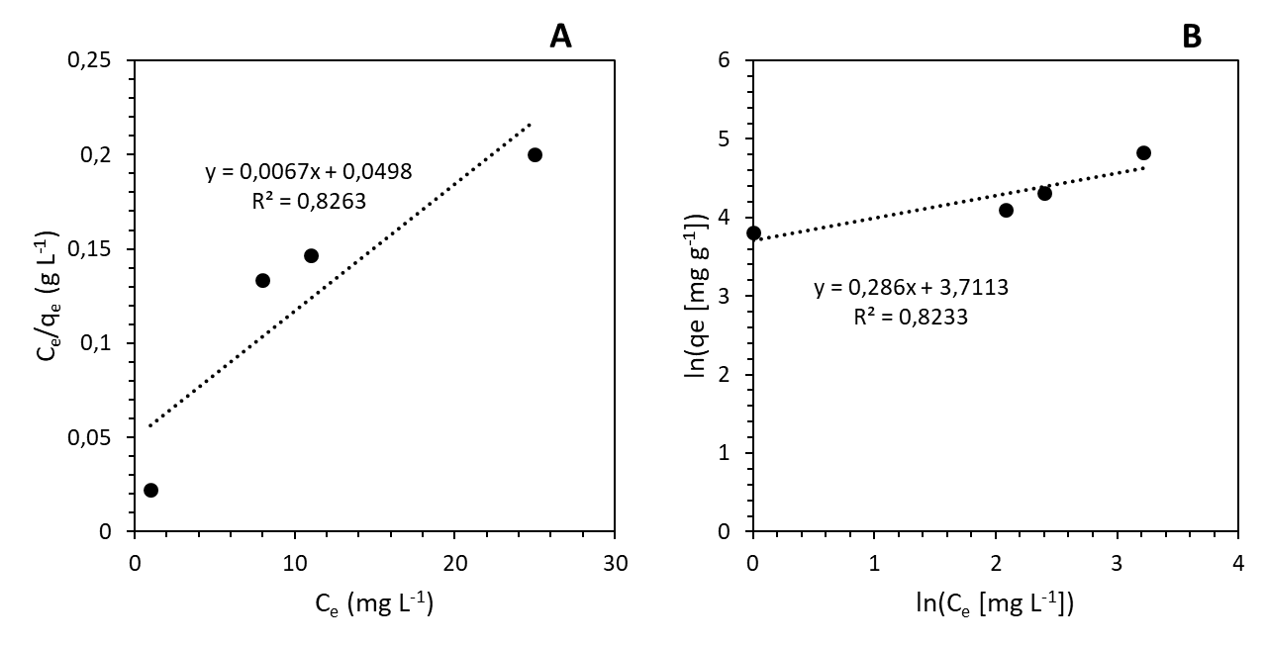
Figure 2: (A) Langmuir, (B) Freundlich adsorption isotherm of Pd (II) onto P41C.

The results show that Pd (II) adsorption occurred on a homogeneous surface via monolayer adsorption with no interaction between the adsorbed metal ions; additionally, the Langmuir isotherm assumes that all surface sites are alike and can only accommodate one adsorbed molecule, that a molecule's ability to be adsorbed on a given site is independent of its neighboring site occupancy, the adsorbed molecule cannot migrate across the surface or interact with neighboring molecules and adsorption is reversible (Govindarajan et al., 2011). As indicated in table 1 the adsorption constants of Langmuir isotherm model parameters, q_{max} and K_{L}, which were calculated using the Langmuir isotherm equation were obtained as 148.498mg/g related to adsorption capacity and 0.135 /mg related to the rate of adsorption, respectively. It is worth noting that the value of q_{max} calculated from the Langmuir model (148.498mg/g), was slightly higher compared to the experimental one (125 mg/g); suggesting that a larger amount of metal ions was needed to form the monolayer coverage (Savastru et al., 2022).

3.2 Kinetics
Adsorption kinetic studies yields information on the adsorption rate, adsorbent performance, and mass transfer mechanisms; understanding adsorption kinetics is critical for designing adsorption systems. (Wang and Gou, 2020). In order to characterize the kinetics of Pd (II) onto P41C, the models pseudo-first order model and pseudo-second order model were utilized for the analysis of the experimental results. The values of the obtained of the coefficient of correlation R², calibrated adsorption capacity q_{e cal} and rate constants K₁ and K₂ obtained from kinetic studies are presented in table 2.
Table 2: Calculated parameters of the Pseudo-First Order and Pseudo-Second Order kinetic models for the adsorption of Pd (II) by P41C
Kinetic Model | Parameter |  |  | Metal: Pd (II) (mg/l)
 |  | 10 | 20 | 30 | 50
 | q_{e} _{exp} (mg/g) | 45.000 | 60.000 | 80.000 | 125.000
 | R² | 0.950 | 0.543 | 0.759 | 0.970
Pseudo-First Order | q_{e cal} (mg/g) | 43.321 | 57.000 | 82.000 | 124.412
 | k₁ | 1.076 x 10⁻¹ | 104.947 | 4,302 x 10⁻² | 5.779 x 10⁻²
 | R² | 0.859 | 0.804 | 0.822 | 0.964
Pseudo-Second Order | q_{e cal} (mg/g) | 42.000 | 63.000 | 75.000 | 126.894
 | k₂ | 7.343 x 10⁻⁵ | 2.791 x 10⁻⁵ | 3.463 x 10⁻⁵ | 4.282 x 10⁻⁵

Graphical representations of the non-linear pseudo-second-order model for the adsorption kinetics of Pd (II) onto P41C; at initial metal concentrations of 10mg/g, 20mg/g, 30mg/g and 50mg/g; biosorbent dosage of 0.1g, pH 3 and room temperature are indicated in figure 3.
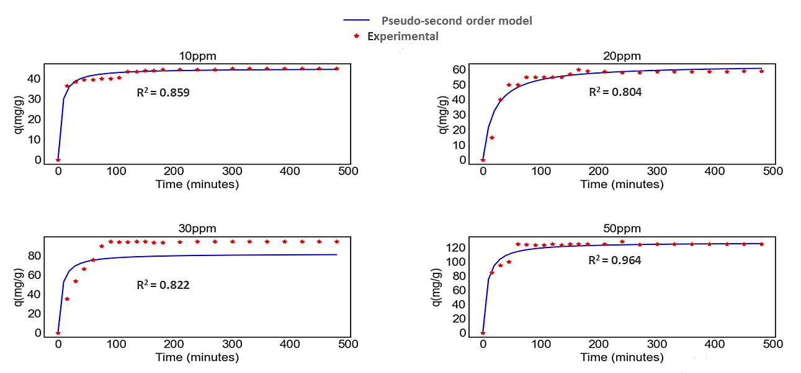
Figure 3: Non-linear representations of the Pseudo-second-order kinetics for the removal of Pd (II) by P41C at initial Pd (II) concentrations of 10 mg/l, 20mg/l, 30 mg/l and 50 mg/; biosorbent dosage of 0.1g, pH 3 and room temperature.

The pseudo-second-order model was found to explain the adsorption kinetics of Pd (II) onto P41C most effectively as indicated by the coefficient of correlation R² value in table 2. According to literature the rate-limiting step of the pseudo-second-order model is the surface adsorption that involves chemisorption, where the removal from a solution is due to physicochemical interactions between the two phases (Wang et al., 2007); therefore this applies to the biosorption of Pd (II) onto P41C. It is worth noting that the q_{e cal} values were very close to the experimental values for Pd (II); the highest deviation was 6% across all the initial metal concentrations of 10mg/g, 20mg/g, 30mg/g and 50mg/g as indicated in table 2.

4. Conclusions
The adsorption isotherm and kinetic studies were effective in comprehending and interpreting the biosorption mechanism pathways for the adsorption of Pd (II) by P41C. The biosorption experimental results from this study indicated that Pd (II) was adsorbed by P41C on a homogeneous surface via monolayer adsorption, this was supported by the Langmuir isotherm model, which was found to be effective in explaining the experimental results. It is also worth noting that the value of q_{max} calculated from the Langmuir model (148.498mg/g), was slightly higher compared to the experimental one (125 mg/g); suggesting that a larger amount of metal ions was needed to form the monolayer coverage. The adsorption kinetics of Pd (II) onto P41C were found to be best explained by the pseudo-second-order model, demonstrating that surface adsorption involves chemisorption, where the removal from a solution is caused by physicochemical interactions between the two phases.

Nomenclature
$q_{e}$ - amount of adsorbed metal at equilibrium, mg/g | $q_{max}$- Langmuir isotherm constant related to maximum monolayer sorption capacity; mg/g | $q_{t}$ - concentration of metal ion species on the biosorbent at time $t$ , mg/g
$C_{0}$ - initial metal concentrations (mg/L), | $K_{L }$- Langmuir isotherm constant related to energy or net enthalpy of adsorption L/mg | $k_{1}$ - equilibrium biosorption constant of pseudo-first-order (1/min).
$C_{e}$ - metal concentrations at equilibrium, mg/L | $K_{f}$ - Freundlich isotherm constant related to biosorption capacity; mg/g | $k_{2}$ - equilibrium biosorption constant of pseudo-second-order (g/mg/min).
$V$- volume (L) | $n$ - Freundlich isotherm constant related biosorption intensity | $m$ - mass of the biosorbent (g).

Acknowledgements
This project was funded by Royal Bafokeng Platinum Mine.

References
AL-Aoh, H.A., Maah, M.J., Ahmad, A.A., Abas, M.R.B. 2012. Adsorption of 4-nitrophenol on palm oil fuel ash activated by amino silane coupling agent.
Desalination and Water Treatment . 40(1-3): 159 – 167
Godlewska-Żyłkiewicz B, Sawicka S, Karpińska J. 2019. Removal of Platinum and Palladium from Wastewater by Means of Biosorption on Fungi Aspergillus sp. and Yeast Saccharomyces sp. Water 11(7): 1522
Govindarajan C., Ramasubramaniam S., Gomathi T., and Sudha P.N. 2011. Studies on adsorption behavior of Cadmium onto nanochitosan- carboxymethyl cellulose blend. Archives of Applied Science Research 3 (5):572 – 580
Mashangoane, B.F., Chirwa, E.N. 2022. Cell surface display of palladium binding peptide on Saccharomyces cerevisiae EBY100 cells using the a-agglutinin anchor system developed for the biosorption of Pd (II). Minerals Engineering 176: 107325
Rangabhashiyam, S., Anu, N., Nandagopal, M. G., & Selvaraju, N. (2014). Relevance of isotherm models in biosorption of pollutants by agricultural byproducts. Journal of Environmental Chemical Engineering 2(1): 398-414
Saitoh, N., Fujimori, R., Yoshimura, T., Tanaka, H., Kondoh, A. Nomura, T., Konishi, Y. 2020. Microbial recovery of palladium by baker's yeast through bioreductive deposition and biosorption. Hydrometallurgy 196: 105413
Savastru, E., Bulgariu, D., Zamfir, C-I, Bulgariu, L. 2022. Application of Saccharomyces cerevisiae in the Biosorption of Co(II), Zn(II) and Cu(II) Ions from Aqueous Media. Water 14(6):976
Sudha, R., Kalpana, K., Rajachandrasekar, T., Arivoli, S. 2007. Comparative study on the adsorption kinetics and thermodynamics of metal ions onto acid activated low cost pandanus carbon. Journal of Chemistry 4: 304305
Syafiqah, M.S.I., Yussof, H.W. 2018. Kinetics, isotherms, and thermodynamic studies on the adsorption of Mercury (II) ion from aqueous solution using modified palm oil fuel ash Materials Today: Proceedings: 5(10): 21690 – 21697
Wang, J., Guo, X. 2020. Adsorption kinetic models: physical meaning, applications, and solving methods. Journal of Hazardous Material 360: 122156
Wang, H., Zhou, A., Peng, F., Yu H., Yang, J. 2007. Mechanism study on adsorption of acidified multiwalled carbon nanotubes to Pb(II). Journal of Colloid and Interface Science. 316(2): 277-283
Won, S.W., Mao, J., Kwak, I-S., Sathishkumar, M., Yun, Y-S. 2010. Platinum recovery from ICP wastewater by a combined method of biosorption and incineration. Bioresource Technology 101: 1135-1140

